**VISVESVARAYA TECHNOLOGICAL UNIVERSITY**

## JNANA SANGAMA, BELGAVI-590018, KARNATAKA

**Mini-Project Report [20MCA37]**

**on**

**“Smart Irrigation”**

*Submitted in partial fulfillment of the requirements for the award of degree of*

#### Master of Computer Applications By

**Pavan S 1RN20MC035**

**Nandan Jayant Hegde 1RN20MC031**

Under the guidance of

#### Ms. Jyothi T

Assistant Professor



## Department of Master of Computer Applications

**RNS Institute of Technology**

Dr. Vishnuvardhan Road, Rajarajeshwari Nagar Post, Channasandra Bangalore - 560 098.

## 2021-2022

RNS INSTITUTE OF TECHNOLOGY

Dr. Vishnuvardhan Road, Channasandra, Rajarajeshwari Nagar Post, Bengaluru - 560 098.

# DEPARTMENT OF MASTER OF COMPUTER APPLICATIONS



**CERTIFICATE**

This is to certify that **Mr. Pavan S** and **Mr. Nandan Jayant Hegde** of 3rd Semester MCA, bearing the **USN: 1RN20MC035** and **1RN20MC031**, has completed their 3rd Sem IoT mini- project topic entitled **“Smart Irrigation”** as a partial fulfilment for the award of the degree of Master of Computer Applications, during the year 2022, under our supervision.

#### Project Coordinator Ms. Jyothi T

Assistant Professor Dept. of MCA, RNSIT Bengaluru – 98.

#### Head of Department Principal

**Dr. N P Kavya Dr. M K Venkatesha**

Head of Department Principal

Dept. of MCA, RNSIT RNSIT

Bengaluru – 98. Bengaluru – 98.

# DECLARATION

We, **Pavan S** and **Nandan Jayant Hegde** students of 3rd MCA, RNS Institute of Technology, bearing **1RN20MC035** and **1RN20MC031** hereby declare that the project entitled **“Smart Irrigation”** has been carried out by me under the supervision of Project Coordinator **Ms. Jyothi T**, Assistant Professor, Department of MCA and submitted in partial fulfillment of the requirements for the award of the Degree of Master of Computer Applications by the Visvesvaraya Technological University during the academic year 2021- 2022. This report has not been submitted to any other Organization/University for any award of degree or certificate.

**Name:** Pavan S

**USN:** 1RN20MC035

**Name:** Nandan Jayant Hegde

**USN:** 1RN20MC031 **Signature of the candidates**

# ACKNOWLEDGEMENT

The successful completion of Mini-Project work depends on the co-operation and help of many people, other than those who directly execute the work. I take this opportunity to acknowledge for the help received for valuable assistance and cooperation from many sources.

Our institution has played a paramount role in guiding us in right direction. I would like to profoundly thank the Management of RNS Institute of Technology for providing such healthy environment for successful completion of this project work.

I express my sincere words of gratitude to our Chairman **Sri Dr. R N Shetty**, for creating an academic environment to brighten our career.

I would also like to thank our beloved Principal, **Dr. M K Venkatesha**, for providing the necessary facilities to carry out this work.

I am extremely grateful to our beloved HoD, **Dr. N P Kavya**, for having accepted to patronize me in the right direction with all her wisdom.

I would also express my heartfelt thanks to our Project Coordinator **Ms. Jyothi T**, Assistant Professor, Department of MCA for her constant guidance and devoted support.

.

**Name:** Pavan S

**USN:** 1RN20MC035

**Name:** Nandan Jayant Hegde

**USN:** 1RN20MC031

# ABSTRACT

India’s population is increasing day by day after 25-30 years there will be significant issue of food, therefore the development of agriculture is important. Today the farmers area unit has shortage of rains and inadequacy of water. In the present era the greatest problem faced by world is water scarcity and agriculture being a demanding occupation consumes plenty of water, therefore a system is required to use the water efficiently. The main objective of this work is to develop a smart and automated watering system for plants and capture Weather data like Temperature and humidity and store all information in cloud for future uses and decision making. Automated systems have fewer manual operations, reliably, flexibility and are accurate. The field of internet of things had a significant transformation to extend things from the data generated from devices to objects in the physical space.

|  |  |  |  |  |
| --- | --- | --- | --- | --- |
|  |  | **TABLE OF CONTENTS** |  |  |
| **Chapter Name** |  | **Page No** |
|  | Declaration |  | i |  |
|  | Acknowledgement Abstract  Table of contents |  | ii iii  iv |  |
|  | List of Tables |  | v |  |
|  | List of Figures |  | vi |  |

#### CHAPTERS

1. INTRODUCTION 01
   1. Project Overview 01
   2. Existing System 02

1.3 Proposed System 02

1. REQUIREMENTS SPECIFICATION 03
   1. Hardware and Software Requirements 03
   2. Hardware Requirements 03
   3. Software Requirements 09
2. ANALYSIS AND DESIGN 10
3. IMPLEMENTATION 11
   1. Source Code 11
   2. Design of the System 15
4. TESTING 16
5. CONCLUSION 18

6.1 Future Enhancement 18

REFERENCES 19

|  |  |  |
| --- | --- | --- |
| **Table No.** | **Name** | **Page No.** |
| 2.1 | Hardware Requirements | 03 |
| 2.2 | Software Requirements | 03 |

|  |  |  |
| --- | --- | --- |
| **Figure No.** | **Name** | **Page No.** |
| 2.1 | Arduino board | 05 |
| 2.2 | Breadboard | 05 |
| 2.3 | Soil Moisture Sensor | 06 |
| 2.4 | 5V Relay Module | 06 |
| 2.5 | Mini Water pump | 07 |
| 2.6 | DHT11 Humidity Temperature Sensor | 07 |
| 2.7 | Gsm 808 Module | 08 |
| 2.8 | Jumper Wires | 08 |
| 3.1 | Circuit diagram of smart irrigation system | 10 |
| 4.2 | Experimental setup | 15 |
| 5.1 | Initial setup | 16 |
| 5.2 | watering Plant | 17 |
| 5.3 | Transferring Data to Database | 17 |
|  |  |  |

**CHAPTER - 1**

**INTRODUCTION**

The term Internet of Things (IoT) was arguably in an online article by Kevin Ashton in 1999, referring first coined to uniquely identifiable objects that are organized in an Internet like structure. Objects in IoT can sense the environment, transfer the data, and communicate with each other. The INTERNET OF THINGS (IoT) has been envisioned as one of the most promising networking paradigms that bridge the gap between the cyber and physical world. The prevalence of IoT leads toward a new digital context for configuring novel applications and services. IoT consists of a variety of things or objects such as RFID tags, sensors, actuators, mobile phones, etc., which are interconnected through both wired and wireless networks to the Internet.

The Internet of things (IoT) can be defined as the inter-networking of physical devices, vehicles (also referred to as "connected devices" and "smart devices"), buildings, and other items embedded with electronics, software, sensors, actuators, and network connectivity which enable these objects to collect and exchange data.

## Project Overview

INIDAS major source of income is from agriculture sector and 70% of people depend on the agriculture, most of the irrigation systems uses traditional methods which are operated manually. Two scare and valuable resources of irrigation that is water and energy are not efficiently utilized by the current irrigation system. Todays advanced society has turned into a digital world through the contribution of technology, now we are leaving in such an era where technology is studied to improve our life style. Hence to make life simpler and convenient SMART IRRIGATION SYSTEM had been introduced. A model of controlling irrigation facilitates to help millions of people.

Smart irrigation system can be defined as the science of artificial application of water to the soil depending on the soil moisture content. With the advent of open source Arduino boards along with the moisture sensor, it is viable to create devices that can monitor the soil moisture content and accordingly irrigating the fields or the land scape when needed. The proposed system makes use of microcontroller ATMEGA328P on Arduino Uno platform and IOT which enables farmers to remotely monitor the status of water level, temperature and humidity in the agricultural field by knowing the sensor values thereby, making the farmers work much easier as they can concentrate on other farm activities.

## Existing System

In existing system, water irrigation is Manuel. Some person should physically Switch on/off water pump for water irrigation. And in the updated systems water irrigation systems can be controlled over phone call using cellular network.

## Proposed System

In proposed system, the water irrigation is done automatically with the help of internet of things (IoT). The soil moister sensor measures the soil moisture and sends value to board. If moisture level is less, then the required moisture to crop the board automatically turns on the water pump and again turns off water pump when soil is enough has moisture using relay module.

The farmer will get to know the status of his form like soil moisture, temperature and humidity remotely using cloud technology. The board regularly updates the data to mongo DB, using GSM module. The data can be further used to some decision making.

# CHAPTER – 2

**REQUIREMENTS SPECIFICATION**

## Hardware and Software Requirements

**Table. 2.1: Hardware requirements**

|  |  |
| --- | --- |
| **Sl.no.** | **Components** |
| 1 | Arduino Uno |
| 2 | Soil Moisture Sensor |
| 3 | DHT11 Temperature and Humidity Sensor |
| 4 | 5V Relay Module |
| 5 | Mini Water Pump |
| 6 | SIM808 GSM/GPRS/GPS Module |
| 7 | Jumper Wires |
| 8 | Breadboard |
| 9 | USB cable |
| 10 | Power adopter |

**Table. 2.2: Software requirements**

|  |  |
| --- | --- |
| **Sl.no.** | **Software** |
| 1 | Arduino ide |

## Hardware Requirements

#### ARDUINO UNO

**Arduino** is an open-source prototyping platform based on easy-to-use hardware and software. Arduino boards are able to read inputs - light on a sensor, a finger on a button, or a Twitter message

- and turn it into an output - activating a motor, turning on an LED, publishing something online. You can tell your board what to do by sending a set of instructions to the microcontroller on the board. To do so you use the Arduino programming language (based on Wiring), and the Arduino Software (IDE), based on Processing.

Arduino was born at the Ivrea Interaction Design Institute as an easy tool for fast prototyping, aimed at students without a background in electronics and programming. As soon as it reached a wider community, the Arduino board started changing to adapt to new needs and challenges, differentiating its offer from simple 8-bit boards to products for IoT applications, wearable, 3D printing, and embedded environments. All Arduino boards are completely open-source, empowering users to build them independently and eventually adapt them to their needs. The software, too, is open-source, and it is growing through the contributions of users worldwide.

## Specification:

Microcontroller [ATmega328P](http://www.atmel.com/Images/doc8161.pdf)

Operating Voltage 5V Input Voltage (recommended) 7-12V Input Voltage (limit) 6-20V

Digital I/O Pins 14 (of which 6 provide PWM output)

PWM Digital I/O Pins 6

Analog Input Pins 6

DC Current per I/O Pin 20 mA

50 mA

DC Current for 3.3V Pin

Flash Memory

32 KB (ATmega328P)

of which 0.5 KB used by bootloader

SRAM 2 KB (ATmega328P)

EEPROM 1 KB (ATmega328P)

Clock Speed 16 MHz

Length 68.6 mm

Width 53.4 mm

Weight 25 g

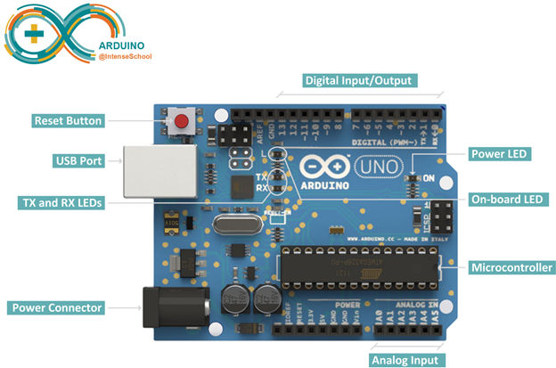

**Figure. 2.1: Arduino board**

#### Breadboard

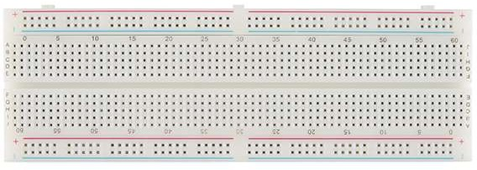

**Figure. 2.2: Breadboard**

A breadboard is a solderless device for temporary prototype with electronics and test circuit designs. Most electronic components in electronic circuits can be interconnected by inserting their leads or terminals into the holes and then making connections through wires where appropriate. The breadboard has strips of metal underneath the board and connect the holes on the top of the board. The metal strips are laid out as shown below.

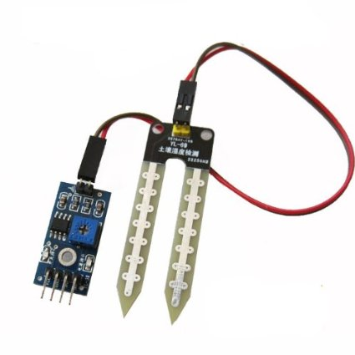**Soil Moisture Sensor**

**Figure. 2.3: Soil Moisture Sensor**

The Soil Moisture Sensor Module determines the amount of soil moisture by measuring the resistance between two metallic probes that is inserted into the soil to be monitored. This can be used in an automatic plant watering system or to signal an alert of some type when a plant needs watering.

**5V Relay Module**

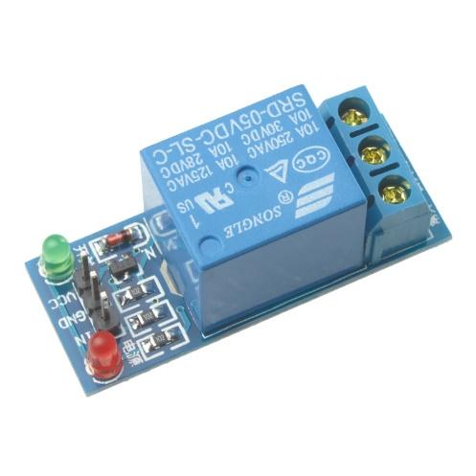Relay is an electromechanical device that uses an electric current to open or close the contacts of a switch. The single-channel relay module is much more than just a plain relay, it comprises of components that make switching and connection easier and act as indicators to show if the module is powered and if the relay is active or not.

**Figure. 2.4: 5V Relay Module**

**Mini Water Pump**

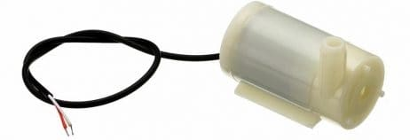

**Figure. 2.5: Mini Water Pump**

This is Micro Submersible Water Pump DC 3V-5V, can be easily integrate to your water system project. The water pump works using water suction method which drain the water through its inlet and released it through the outlet. You can use the water pump as exhaust system for our aquarium and controlled water flow fountain

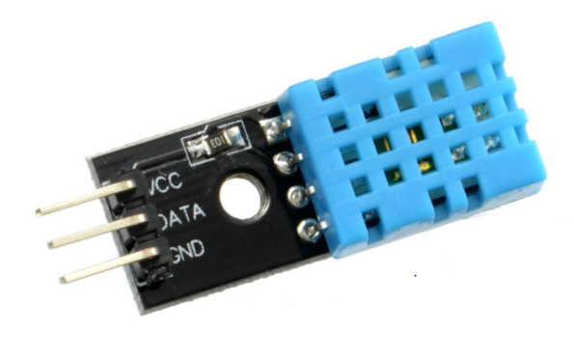**DHT11 Humidity Temperature Sensor**

**Figure. 2.6: DHT11 Humidity Temperature Sensor**

The DHT11 is a basic, ultra-low-cost digital temperature and humidity sensor. It uses a capacitive humidity sensor and a thermistor to measure the surrounding air. It spits out a digital signal on the data pin.

It’s simple to use but requires careful timing to grab data. The only real downside of this sensor is you can only get new data from it once every 2 seconds. So when using the library, sensor readings can be up to 2 seconds old. In this project, we will use this sensor to measure the air temperature and humidity.

#### Jumper Wires

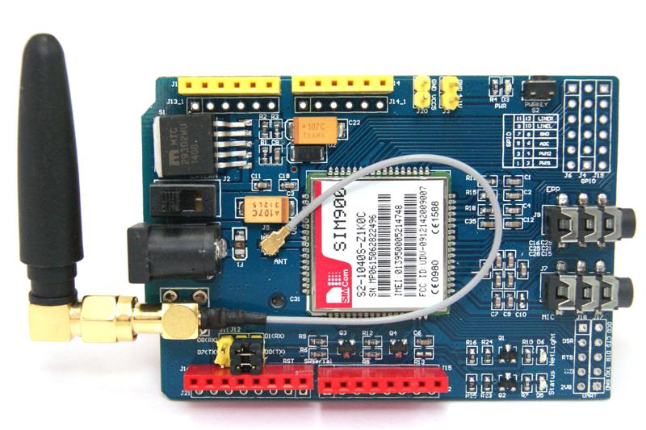

**Figure. 2.7: Gsm 808 Module**

This is a GSM & GPS Modem based on Simcom's SIM808 Module. This GSM-GPS Modem is perfect for projects which require both GSM Modem & GPS Module. SIM808 module is a GSM and GPS two-in-one function module. It is based on the latest GSM/GPS module SIM808 from SIMCOM, supports GSM/GPRS Quad-Band network and combines GPS technology for satellite navigation.

#### Jumper Wires

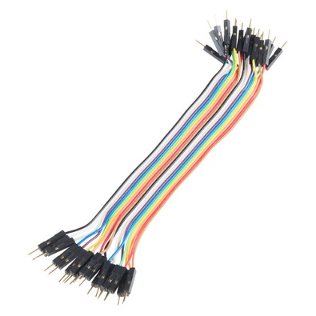

**Figure. 2.8: Jumper wires**

Jumper wires are simply wiring that have connector pins at each end, allowing them to be used to connect two points to each other without soldering. Jumper wires are typically used with breadboards and there are three types of jumper wires male to male, female to female, male to female.

## Software Requirements

#### Arduino IDE

The **Arduino Integrated Development Environment (**[**IDE**](https://en.wikipedia.org/wiki/Integrated_development_environment)**)** is a [cross-platform](https://en.wikipedia.org/wiki/Cross-platform) application that is written in functions from [C](https://en.wikipedia.org/wiki/C_(programming_language)) and [C++.](https://en.wikipedia.org/wiki/C%2B%2B_(programming_language)) It is used to write and upload programs to [Arduino](https://en.wikipedia.org/wiki/Arduino) compatible boards.

# CHAPTER-3

**ANALYSIS AND DESIGN**

## 3.1 Circuit Diagram:

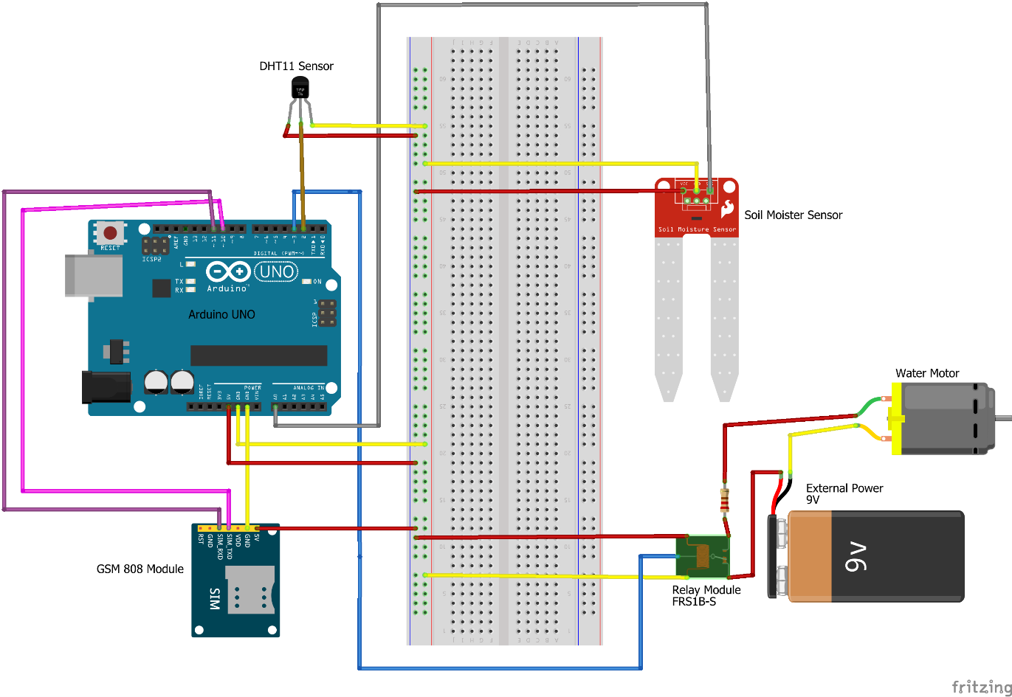

**Figure. 3.1: Circuit diagram of smart irrigation system**

The above diagram shows the pin diagram of our model. It consists of one Arduino Uno, mini water motor, 5V relay, Soil moisture sensor, DHT11 and Gsm module. The Arduino Uno is the brain of our system which powers all other devices except water pump. The water pump gets power supply from external power source to that relay acts as a switch. Arduino and Gsm module are connected with Tx and Rx serial communication for network operations.

# CHAPTER – 4

**IMPLEMENTATION**

## Source Code:

#include "DFRobot_sim808.h"

#include "DHT.h"

#include "SoftwareSerial.h"

#include "ArduinoJson.h"

SoftwareSerial myserial(10,11); //rx 10, tx 11

#define DHTPIN 2 // Digital pin connected to the DHT sensor

#define soil_s A0

#define DHTTYPE DHT11 // DHT 11

float soil_moist,temp,humidity;

int motorstatus,count=0;

char deviceID[10] = "ROYAL256";

StaticJsonDocument<200> doc;

DFRobot_SIM808 sim808(&myserial);

DHT dht(DHTPIN, DHTTYPE);

int motor_on();

int send_wethardata();

void ShowSerialData();

void setup() {

pinMode(3,OUTPUT);

digitalWrite(3,HIGH);

pinMode(1,INPUT);

myserial.begin(9600);

Serial.begin(9600);

dht.begin();

while(!sim808.init()) {

Serial.print("Sim808 init error\r\n");

delay(1000);

}

}

void loop() {

ShowSerialData();

soil_moist = analogRead(soil_s);

soil_moist = map(soil_moist,550,10,0,100);

temp = dht.readTemperature();

humidity = dht.readHumidity();

if(soil_moist <= 0)

{

motor_on();

}

else

{

digitalWrite(3,HIGH);

motorstatus = 0;

}

Serial.print(humidity);

Serial.println("hum ");

Serial.print(temp);

Serial.println("C ");

Serial.print(soil_moist);

Serial.println("%");

Serial.println("******");

Serial.print("Recieved Message: ");

Serial.println(message);

if(count>=60)

{

send_wethardata();

count=0;

}

count+=1;

ShowSerialData();

delay(60000);

}

int motor_on()

{

digitalWrite(3,LOW);

motorstatus = 1;

Serial.println("motor on @");

}

int send_wethardata()

{

if (myserial.available())

Serial.write(myserial.read());

myserial.println("AT");

delay(1000);

myserial.println("AT+SAPBR=3,1,\"Contype\",\"GPRS\"");

delay(3000);

ShowSerialData();

myserial.println("AT+SAPBR=3,1,\"APN\",\"www\"");//APN

delay(3000);

ShowSerialData();

myserial.println("AT+SAPBR=1,1");

delay(3000);

ShowSerialData();

myserial.println("AT+SAPBR=2,1");

delay(3000);

ShowSerialData();

myserial.println("AT+HTTPINIT");

delay(3000);

ShowSerialData();

myserial.println("AT+HTTPPARA=\"CID\",1");

delay(3000);

ShowSerialData();

// StaticJsonDocument<200> doc;

doc["temp"] = temp;

doc["humidity"] = humidity;

doc["soilmoist"] = soil_moist;

doc["motorstatus"] = motorstatus;

serializeJson(doc, Serial);

String sendtoserver;

serializeJsonPretty(doc, sendtoserver);

delay(3000);

myserial.println("AT+HTTPPARA=\"URL\",\"http://smart-irrigation-iot.herokuapp.com/se\""); //Server address

delay(3000);

ShowSerialData();

myserial.println("AT+HTTPPARA=\"CONTENT\",\"application/json\"");

delay(3000);

ShowSerialData();

myserial.println("AT+HTTPDATA=" + String(sendtoserver.length()) + ",100000");

Serial.println(sendtoserver);

delay(3000);

ShowSerialData();

myserial.println(sendtoserver);

delay(3000);

ShowSerialData;

myserial.println("AT+HTTPACTION=1");

delay(3000);

ShowSerialData();

myserial.println("AT+HTTPREAD");

delay(6000);

ShowSerialData();

myserial.println("AT+HTTPTERM");

delay(10000);

ShowSerialData;

}

void ShowSerialData()

{

while (myserial.available() != 0)

Serial.write(myserial.read());

delay(1000);

}

## Design of the System

The picture shows the model of the smart irrigation system.

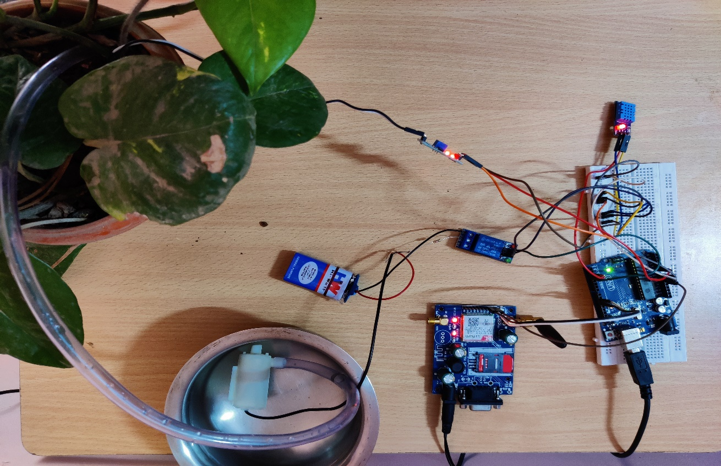

**Figure.4.2 Experimental setup**

The Arduino board is interfaced with Gsm 808 module, DHT11 sensor, soil moisture sensor, relay module to deduct Soil moisture and switch on/off the water pump. The microcontroller board Arduino Uno along with moisture detection sensor soil moister in the soil and based on required moister to crop the water irrigation is made. Every hour The Data captured current temperature, humidity and soil moisture is transferred through a Gsm module through Cellular network. The Data hits our API which is deployed on Heroku. Our Application at Server validates and process the incoming data and processed Data is sent to Mongo DB Non-Relational database to store the Data for future Use and decision.

# CHAPTER – 5

**TESTING**

## Test case 1: Initial setup

The below diagram shows the initial case of the system when we turn on our project, which keep on sensing temperature, humidity and soil moisture for every five minutes and sends the log to connected computer through serial communication port.

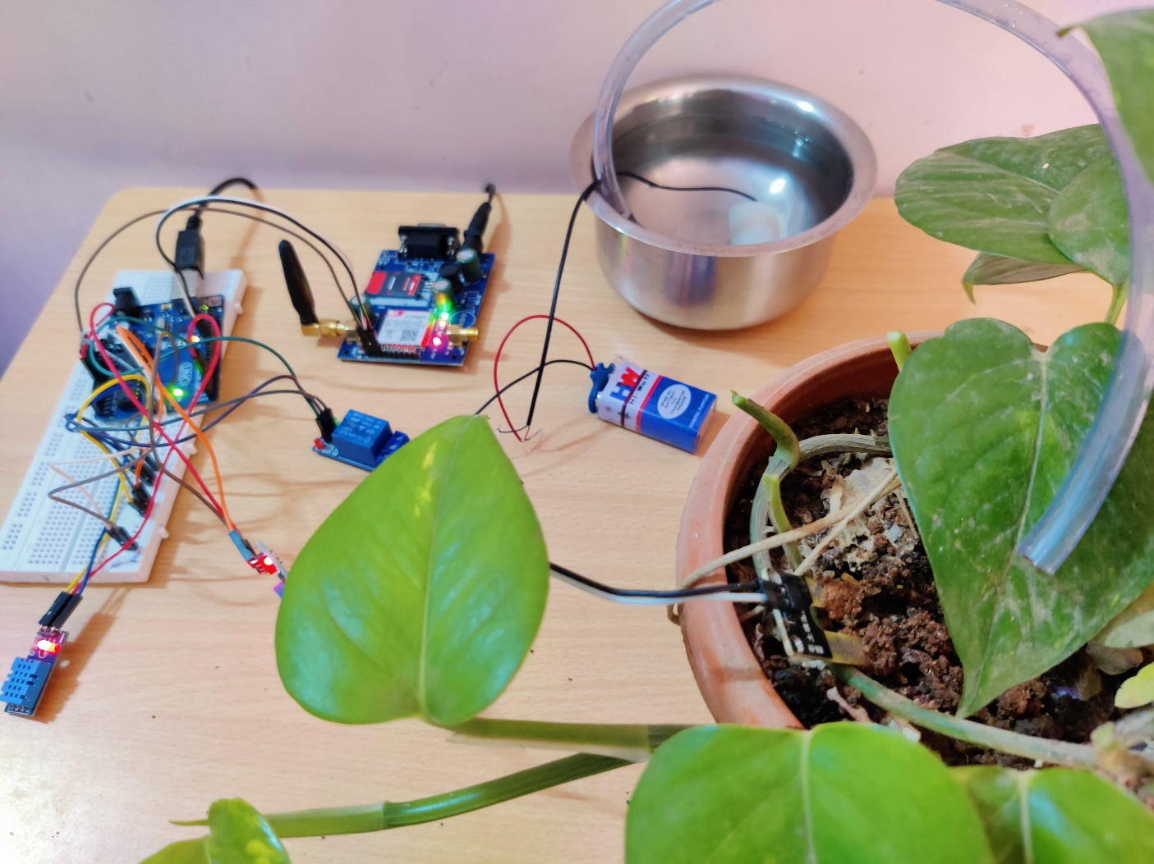

**Figure.5.1: initial setup**

## Test case 2: Soil is Dry

The below diagram shows when the soil has low moisture content and crop need water. The microcontroller automatically triggers relay to switch on the water pump.

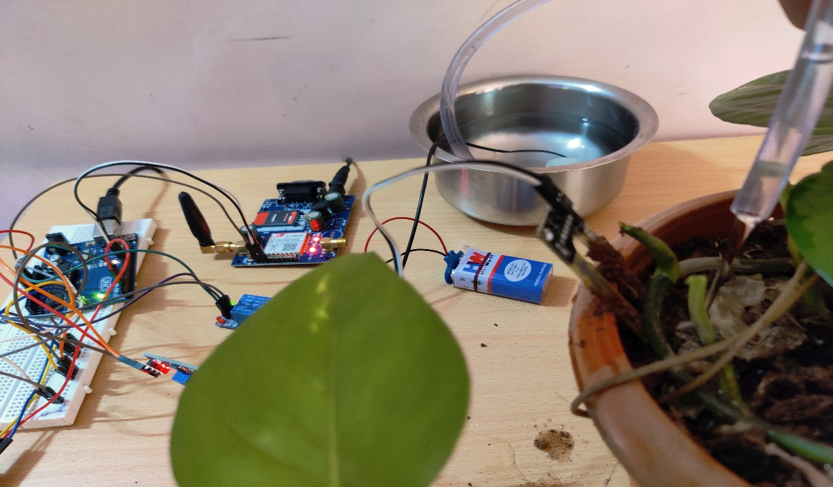

**Figure.5.2: watering Plant**

## Test case 3: Transferring Data to Database

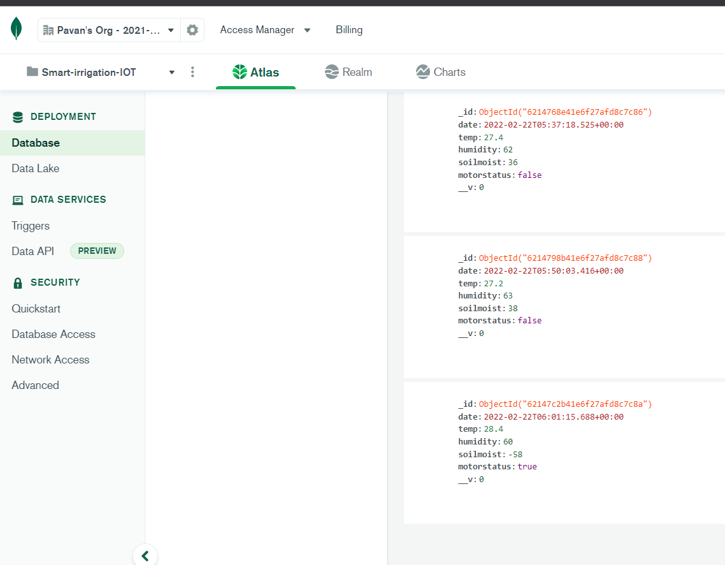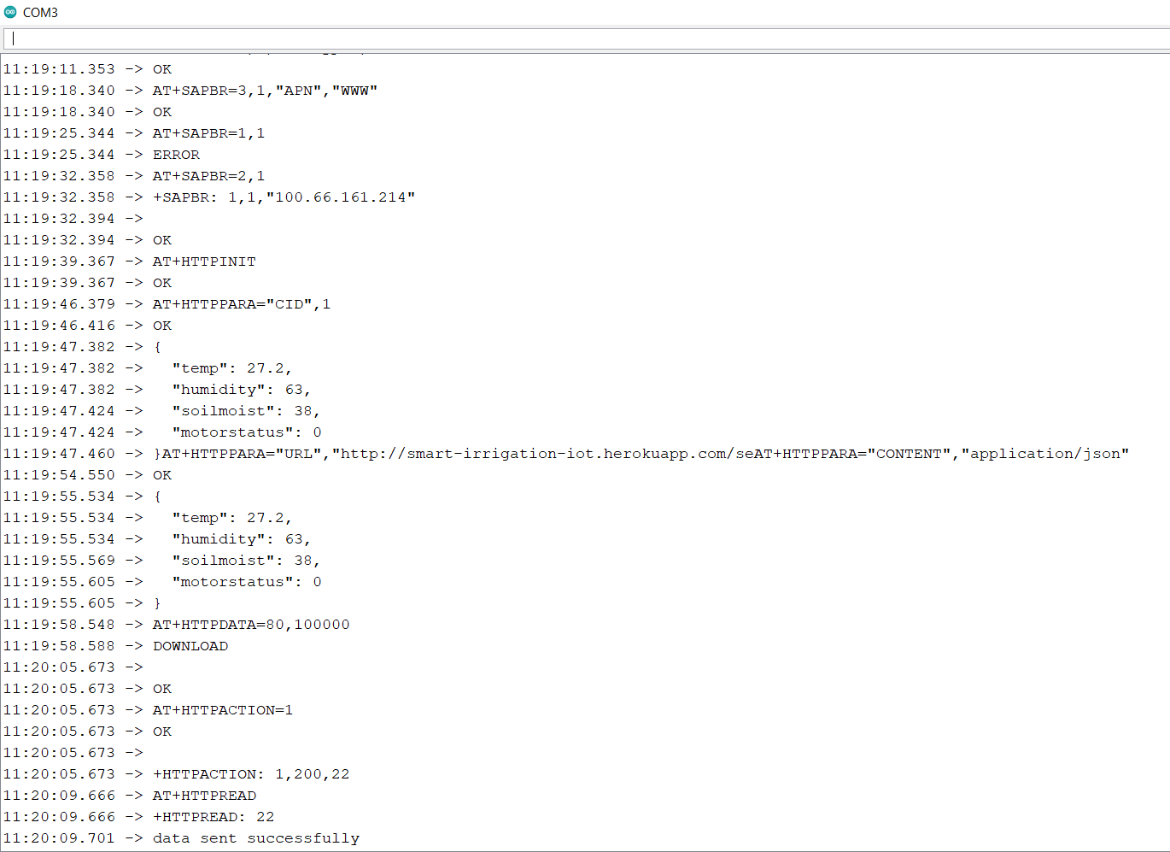The below diagram shows Arduino board connected with Gsm module through Tx, Rx serial connection establish cellular network connection with network provider. Converts the data into Json format and Transfers the Data through HTTP POST method. As soon as Request hits the server the server application validates, process and store the data into mongo DB.

**Figure.5.3: Transferring Data to Database**

# CHAPTER – 6

**CONCLUSION**

In present days, in the field of agriculture farmers are facing major problems in watering their crops. It’s because they don’t have proper idea about the availability of the power. Even if it is available, they need to pump water and wait until the field is properly watered, which compels them to stop doing other activities – which are also important for them, and thus they loss their precious time and efforts. but there is a solution – a smart plant irrigation system not only helps farmers but also others for watering their gardens as well.

This Smart irrigation system senses the moisture content of the soil and automatically switches the pump when the power is on. A proper usage of irrigation system is very important because the main reason is the shortage of land reserved water due to lack of rain, unplanned use of water as a result large amounts of water goes waste. For this reason, we use this smart plant watering system, and this system is very useful in all climatic conditions.

## Future Enhancement

This smart irrigation system project can be enhanced by Weather-based smart irrigation controllers. Weather-based controllers, also referred to as evapotranspiration (ET) controllers, use local weather data to adjust irrigation schedules. Evapotranspiration is the combination of evaporation from the soil surface and transpiration by plant materials. These controllers gather local weather information and make irrigation run-time adjustments, so the landscape receives the appropriate amount of water.

ET weather data uses four weather parameters: temperature, wind, solar radiation and humidity. It’s the most accurate way to calculate landscape water needs.

# REFERENCES

1. Abdul Ahad, Zishan Raza khan, Syed Aqeel Ahmad,” Intelligent parking System” Scientific Research Publishing, Vol.4, No.2,pp.160-167, May 2016
2. <https://friendtechbd.com/interface-gsm-sim808-module-to-arduino-callingsend-and-receive-sms/> - To Interface GSM Sim808 Module to Arduino
3. <https://www.electricaltechnology.org/2018/08/automatic-plant-watering-irrigation-system.html> - Automatic Plant Watering & Irrigation System
4. <https://how2electronics.com/sim900-800-http-post-request-json-format-arduino/>

- HTTP Post Request in JSON Format with Arduino